PROJECTION,LIMITS & SELECTORS

IT IS USED TO WHEN YOU DON’T WANT TO DISPLAY ALL THE ATTRIBUTES IN THE OUTPUT.

**db.students.find({},{name:1,gpa:1}).count();**

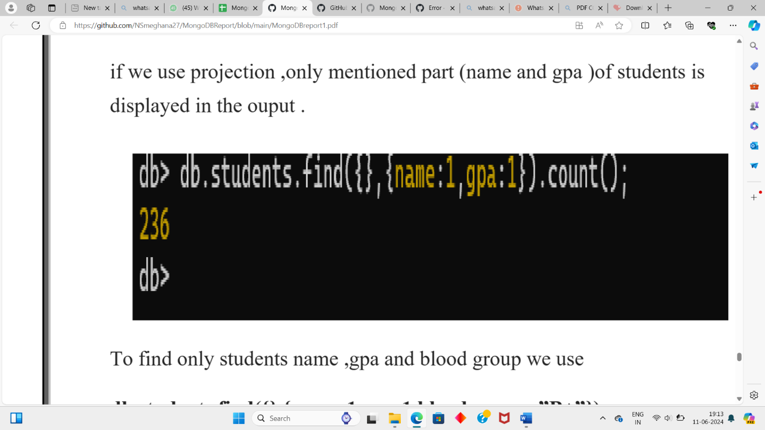

**To find countings:**

**Db.students.find({},{name:1,gpa:1,blood_group:”B+”});**

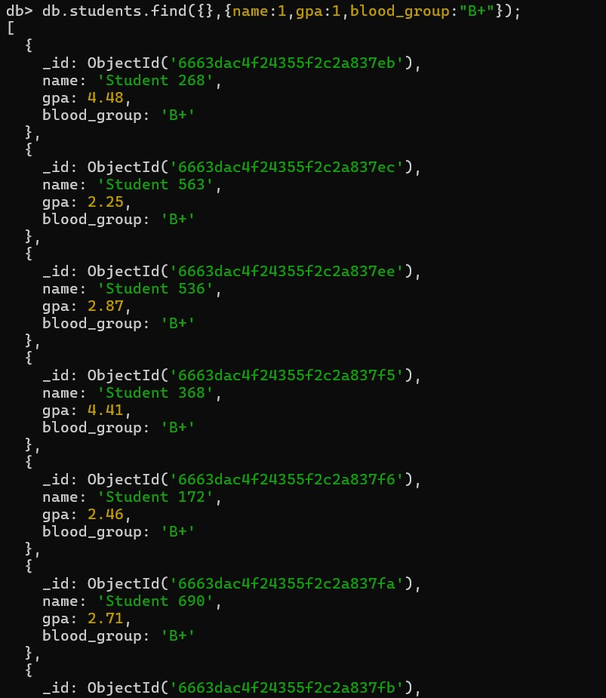

**To display collection without an id**

**db.students.find({},{_id:0});**

